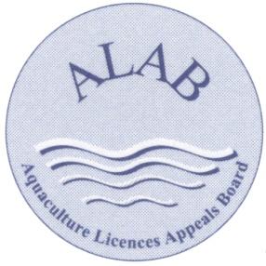
An Bord Achomharc Um Cheadúnais Dobharshaothraithe
Aquaculture Licences Appeals Board

Subject Access Request Form for Personal Data/Records under the Data Protection Acts and
the General Data Protection Regulation (GDPR)
To: Data Protection Officer,
Aquaculture Licences Appeals Board
Kilminchy Court
Portlaoise,
Co. Laois
R32 DTW5
email: dataprotection@alab.ie

Please use BLOCK letters
Applicant's Name:

Postal Address:

Eircode:
Daytime Telephone Number:
Email address:

In accordance with Article 15 of the General Data Protection Regulation (GDPR), I request access to my personal records as detailed below.
In the space provided below, please describe the personal records you are requesting, as fully as you can. The Data Protection legislation only provides for access to personal data of the requester. Third party information will not be released.
Before you are given access to personal information, you must provide proof of your identity (e.g. copy of Driver’s Licence or Passport).
I request the following records:

My preferred form of access is: (please tick as appropriate)
To receive copies of the records by post electronic
PLEASE SIGN HERE | DATE:
Privacy Notice:

Please note that the personal information contained here will only be used in connection with the administration of the Data Protection Subject Access Request, as outlined above. Information collected will be held safety and securely and will not be shared outside ALAB.

